**EXPERIMENT NO:10**

**NAME:CHIRAG ROHRA ROLL NO:57**

**1.Bezier curve:**

**PROGRAM:**

#include<stdio.h>

#include<conio.h>

#include<dos.h>

#include<graphics.h>

void main()

{

clrscr();

int gd=DETECT,gm;

int x[4],y[4],px,py,i,n;

double t;

initgraph(&gd,&gm,"C:/TC/BGI");

printf("Enter the no of control points:");

scanf("%d",&n);

printf("Enter the control points of bezier curve: ");

for(i=0;i<n;i++)

{

scanf("%d%d",&x[i],&y[i]);

putpixel(x[i],y[i],GREEN);

}

for(t=0.0;t<=1.0;t+=0.001){

px=(1-t)*(1-t)*(1-t)*x[0]+3*t*(1-t)*(1-t)*x[1]+3*t*t*(1-t)*x[2]+t*t*t*x[3];

py=(1-t)*(1-t)*(1-t)*y[0]+3*t*(1-t)*(1-t)*y[1]+3*t*t*(1-t)*y[2]+t*t*t*y[3];

putpixel(px,py,WHITE);

delay(2);

}

getch();

closegraph();

}

**OUTPUT:**

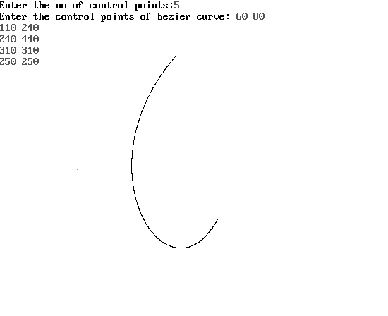

**2.KOCH CURVE:**

**PROGRAM:**

#include<graphics.h>

#include<conio.h>

#include<math.h>

void koch(int x1, int y1, int x2, int y2, int it)

{

float angle = 60*M_PI/180;

int x3 = (2*x1+x2)/3;

int y3 = (2*y1+y2)/3;

int x4 = (x1+2*x2)/3;

int y4 = (y1+2*y2)/3;

int x = x3 + (x4-x3)*cos(angle)+(y4-y3)*sin(angle);

int y = y3 - (x4-x3)*sin(angle)+(y4-y3)*cos(angle);

if(it > 0)

{

koch(x1, y1, x3, y3, it-1);

koch(x3, y3, x, y, it-1);

koch(x, y, x4, y4, it-1);

koch(x4, y4, x2, y2, it-1);

}

else

{

line(x1, y1, x3, y3);

line(x3, y3, x, y);

line(x, y, x4, y4);

line(x4, y4, x2, y2);

}

}

int main(void)

{

int gd = DETECT, gm;

initgraph(&gd, &gm, "C:/TC/BGI");

int x1 = 100, y1 = 100, x2 =400, y2 = 400;

koch(100,100,300,100,0);

koch(100,200,300,200,1);

koch(100,300,300,300,2);

getch();

return 0;

}

**OUTPUT:**

